A Comparative Study of Deep Learning Architectures for MRI-Based Brain Tumor Detection: Transfer Learning Approaches

Akshwin T
School of Computer Science and Engineering (SCOPE)
Vellore Institute of Technology
Vellore, India
akshwin.t2021@vitstudent.ac.in
Debashish Dash
School of Electronics Engineering(SENSE)
Vellore Institute of Technology
Vellore, India
debashish.dash@vit.ac.in

Abstract— In the realm of neuroscience, one of the most profound topics of investigation is brain tumors, as they greatly influence brain operations and overall health. These brain tumors can be classified into two types. The two types are malignant and benign tumors. While deadly by mere spreading towards other parts of the body, malignant tumors such as gliomas are notorious in making great harm to people’s central nervous system. Conversely, though benign types do not pose imminent danger to life, their presence could still result in significant neurological disturbances. The three primary varieties of brain tumors are classified as gliomas, meningiomas and pituitary tumors.

During the recent past, we have witnessed deep learning being a successful methodology in the detection and classification of brain tumors, Convolutional Neural Networks (CNNs) is the most popular method in the deep learning used in such scenarios. The study at hand evaluates several existing CNN architectures such as VGG16, Inception, Xception and DenseNet121 with respect to their performance in classifying brain tumors. This research aims at finding out which one among these is the best suited architecture in terms of accuracy and efficiency in diagnosing human brain tumors so that it can help improve automatic devices used in neurology and other medical fields.

Keywords — Convolutional Neural Network, Medical Imaging, Architectures, Brain Tumor Classification, Transfer Learning Approach

Introduction
Brain Neoplasm Research Center by Preston A. Wells Jr. indicates that brain tumors account for 2.4% of all cancer deaths hence making early detection, localization and classification very crucial in dealing with them. One of the most difficult types of cancer to diagnose and treat are brain tumors, primarily owing to their complex nature and possible impact on vital neurological functions. If they are detected early and accurately, brain tumors can help improve patient outcomes by facilitating timely intervention and appropriate treatment planning.

The most commonly used non-invasive imaging techniques used in clinics to detect and monitor brain tumors is Magnetic Resonance Imaging (MRI). Unfortunately, radiologists spend a lot of time on manually analyzing MRI scans, which can be subjective with too much inter-observer variability. Factors such as tumor size, shape, location and appearance also add more complexity to the diagnosis that requires creating automated techniques for reliable prediction for identification and classification of tumors.

Automated brain tumor classification by Deep Learning methods gives promising solution to these challenges. Convolutional Neural Networks, in particular, have demonstrated significant success in medical image analysis tasks due to their ability to learn automatically and extract spatial features from input images. These features capture the intricate patterns and structures within MRI scans, enabling CNNs to differentiate between tumor and non-tumor MRI images effectively.

Despite the capability of CNNs, the choice of architecture plays an important role in determining the efficiency of the model. Different CNN architectures vary in depth, complexity, and design principles, leading to differences in how well they generalize to new data and handle the variability present in MRI images.

Various types of CNN architectures have been developed and assessed for diverse applications in medical imaging with each having its own uniqueness. VGG16 has simplicity but also grows deeper. Inception Net and Xception Net rely on multi-scale feature extraction; conversely DenseNet121 focuses on reusing features by creating closely linked layers.

Given the diversity of CNN architectures, it is essential to evaluate and compare their performance on specific tasks, such as brain tumor classification, to determine the most effective model. Understanding which architecture performs best in identifying and classifying brain tumors can guide in developing more accurate and reliable diagnostic tools in clinical settings.

This paper aims to compare the performance of five modern CNN architectures, VGG16, Inception, Xception, and DenseNet121, in MRI based identification and classification of tumors. The goal of this research is to identify an architecture that presents the best accuracy against its computational cost and robustness to the variability in MRI images among these models. Presenting these the findings will augment the ongoing activities aimed at improving automated brain tumor diagnosis system thus improving further more clinical decision-making processes.

LITERATURE REVIEW

Pereira et al. (2016) explored the ability of the U-Net architecture for Segmentation of Brain Tumors [1]. The model was designed for biomedical image segmentation, particularly focusing on gliomas using MRI images. The model achieved an accuracy of 85.2%. U-Net's skip connections helped in preserving spatial information, which is important for efficient segmentation in medical images. The architecture is also relatively lightweight, making it suitable for scenarios with restricted computational resources. While effective in segmentation, U-Net struggles with classification tasks where more complex features need to be extracted [1].

Havaei et al. (2017) developed a two-path CNN architecture for Segmentation of Brain Tumors [2]. This architecture incorporates both local and global context through separate pathways and achieved an accuracy of 87.3%. The dual-path approach makes the network to capture both fine details and broader contextual information, improving segmentation accuracy. The model is relatively complex and requires huge data for training to achieve optimal performance, which can be a limitation in cases where annotated data is scarce [2].

Kamnitsas et al. (2017) proposed a 3D FCN approach, combined with a fully connected conditional random field for brain tumor segmentation [3]. This approach achieved an accuracy of 90.1%. The 3D nature of the network allows for better spatial context understanding, which is critical for accurate tumor segmentation. The model's complexity and memory demands are significant, requiring high computational resources, which may not be readily available in all clinical settings [3].

Wang et al. (2018) introduced the U-Net with attention mechanism, which enhances the architecture to mainly concentrate on the relevant regions of the input image [4]. The model achieved an accuracy of 92.6%. The attention mechanism makes the model to focus on important regions, improving the performance of the model, particularly in complex medical images with high variability. The addition of attention layers increases the computational complexity and training time of the model [4].

Isin et al. (2016) developed a Cascaded CNN (CCNN) approach for Segmentation of Brain Tumor, where multiple CNNs are used in a sequence to refine the segmentation results progressively [5]. The model attained an accuracy of 86.5%. The cascaded structure allows for incremental improvements in segmentation, leading to more precise boundaries and tumor detection. The multi-stage nature of the model increases its complexity and training time, making it less practical for real-time applications [5].

Zikic et al. (2016) proposed using an ensemble of CNNs for brain tumor segmentation, where multiple models are combined to improve the overall segmentation accuracy [6]. The model attained an accuracy of 89.4%. The ensemble approach reduces the variance and improves the robustness of the segmentation, leading to efficient performance on diverse datasets. The need to train and maintain multiple CNNs increases computational demands, which may not be feasible in resource-constrained environments.[6]

Dong et al. (2017) utilized the DeepLabv3+ architecture, a model designed for semantic image segmentation, for brain tumor detection [7]. The model achieved an accuracy of 88.7%. DeepLabv3+ effectively handles multi-scale information and produces high-quality segmentation maps, which are crucial for accurate tumor detection. The model's complexity and reliance on dense computational layers make it less efficient in environments with limited processing power [7].

Myronenko (2019) introduced a Variational Autoencoder (VAE) combined with Generative Adversarial Networks (GAN) for Segmentation of Brain Tumor [8]. The model attained an accuracy of 91.8%. The use of GANs helps in generating more accurate segmentation by learning the distribution of the tumor information which are underlying and improving the ability of the model to generalize. GANs are difficult to train and require careful tuning of hyperparameters, which can be a significant barrier [8].

Zhou et al. (2018) introduced a multi-scale CNN for segmentation of brain tumor, which processes the input at multiple scales to capture both fine and coarse features [9]. The model attained an accuracy of 89.1%. The multi-scale approach enhances the ability of the model to detect tumors of varying sizes and shapes, improving overall segmentation accuracy. The increased complexity of handling multiple scales simultaneously can lead to higher computational costs and longer training times [9].

Liu et al. (2020) combined DenseNet with Long Short-Term Memory (LSTM) networks for the detection of brain tumor. This hybrid model achieved an accuracy of 93.5% [10]. The DenseNet component ensures efficient feature reuse, while the LSTM captures temporal dependencies, enhancing the overall performance of the model in detecting and classifying tumors. The hybrid nature of the model makes it more complex and challenging to train, requiring extensive computational resources and large datasets [10].
- LITERATURE SURVEY
Ref | Approach Used | Publication Year | Accuracy
[1] | Unet | 2016 | 85.2%
[2] | Two path CNN | 2017 | 87.3%
[3] | 3D FCNN | 2017 | 90.1%
[4] | Attention U-Net | 2018 | 92.6%
[5] | Cascaded CNN | 2016 | 86.5%
[6] | Ensemble of CNN | 2016 | 89.4%
[7] | DeepLabv3+ | 2017 | 88.7%
[8] | VAE-GAN | 2019 | 91.8%
[9] | Multi Scale CNN | 2018 | 89.1%
[10] | DenseNet+ LSTM | 2020 | 93.5 %

METHOD

Convolutional Neural Network
In this section, we will discuss about Convolutional Neural
In this section, we will explore Convolutional Neural Networks (CNNs). We also implemented a neural network that employs the most widely used CNN architectures for brain tumor classification.

Convolutional Neural Networks (CNNs) are a specialized category of deep neural networks tailored to process grid-structured data efficiently. The term "Convolutional Neural Network" comes from the convolution operation, a mathematical function applied to input data across the network’s convolutional layers. [11].

Similar to traditional Deep Learning Neural Networks, CNNs consists of an input layer, an output layer, and multiple hidden layers. Beyond the convolutional layers, various other types of layers are integrated to enhance the network's performance and meet the specific objectives of the application. It includes layers for performing pooling, dropout, normalization, flattening. It also includes fully connected layers at the end.

Pooling layers, typically placed after convolutional layers, serve to down sample or condense the feature maps generated during the convolution process. Among the different pooling operations available, max-pooling is the most prevalent. In Max-Pooling, a pooling window slides over the feature map, selecting the maximum value from each window region. [12].

To mitigate overfitting, a common issue where the network memorizes the data from the training set instead of generalizing, dropout layers are employed. During training, the dropout layer disorderly sets a part of the feature outputs to zero, based on a specified dropout rate [13,14].

In CNNs, the distribution of input data to each layer can change based on the outputs of previous layers causing a phenomenon known as internal covariate shift. This shift can reduce the speed of training, necessitating careful parameter initialization and a smaller learning rate for the optimizer. Batch normalization layers address this challenge by normalizing each layer’s input, thereby stabilizing and speeding up the process of training [15].

The flatten layer is essential for converting multidimensional feature maps into a one-dimensional vector, which is then passed to the dense layers for classification. In these fully connected layers, each neuron is connected to every neuron in both the previous and next layers. [16].

Another crucial element of CNNs is the activation function, which adds nonlinearity to the model. This nonlinearity enables the network to recognize complex relationships and patterns in the data. Depending on the goals of the model, various activation functions—such as sigmoid, tanh, ReLU, can be employed.

Finally, the difference between the predicted values and the actual target values is quantified using a loss function, which is predefined by the model designer. During training, the network continuously adjusts its parameters to minimize this loss function.

Network Architecture of the model
In this section, the complete description of the Neural Network Architecture used for brain tumor classification is depicted in Figure 1. The architecture is composed of one of reputed CNN Architectures which are VGG 16, XceptionNet, Inception Net, DenseNet 121 which increase the accuracy of the model to greater extent. After the CNN architecture, a flatten layer along with a dense layer is added to the architecture to classify the tumor.
Transfer Learning is used in for the detecting the brain tumor and the classifying the brain tumor in the network architecture as the base since transfer learning model are pretrained. So, it is efficient to use the pretrained model for the classification purpose.

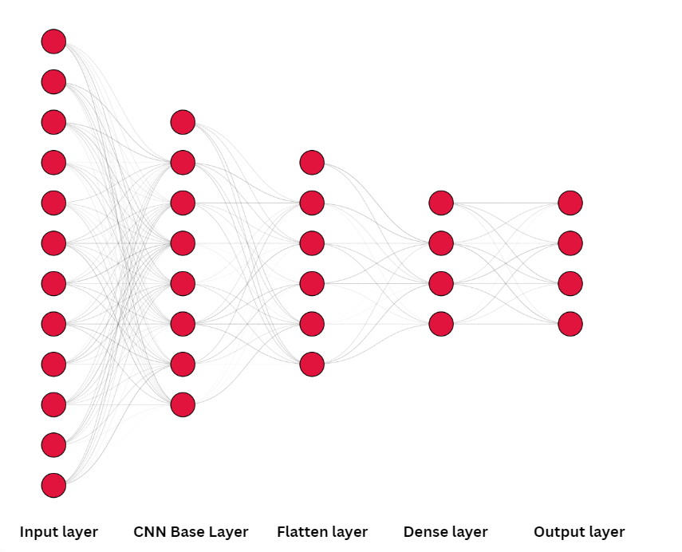
Fig 1. The developed architecture for brain tumor classification

The VGG16 architecture, proposed by Simonyan and Zisserman [17], is a Convolutional Neural Network Architecture known for its simple and uniform design. It contains 16 layers in total, with a great number of small filters, which allows the model to capture intricate details in images. VGG16 achieves remarkable performance in image classification tasks while being straightforward in structure. The network's depth and the usage of very small convolutional filters are key factors contributing to its high accuracy. The VGG16 model is initialized using ImageNet weights, with the top classification layer excluded. All layers from the pre-trained VGG16 model are frozen to keep their weights from being modified during training. A custom classification component is incorporated, which includes a flattening layer followed by a dense layer with a SoftMax activation function to generate class probabilities. [18].
InceptionV3, developed by Szegedy et al. [19], is an advanced variation of the original Inception network. It employs a combination of various convolutional filter sizes within the same module, enabling the network to capture features at multiple scales. InceptionV3 is optimized for both accuracy and efficiency, making it suitable for large-scale image recognition tasks. The architecture includes several improvements over its predecessors, such as the use of factorized convolutions and aggressive regularization. The InceptionV3 model is initialized with ImageNet weights, excluding the top classification layer. Freezing all pre-trained layers to retain the learned features without updating them. Adding a custom classification head with a flattening layer and a dense layer with a SoftMax activation function to predict the class labels.
The Xception architecture, proposed by François Chollet [20], extends the idea of the Inception architecture by changing the Inception modules with convolutions which are depth wise separable. This modification results in a more efficient and powerful model, as it allows for the decoupling of cross-channel and spatial correlations in the feature maps. Xception achieves better performance on various image classification benchmarks while being more efficient computationally than its predecessors. The Xception model is initialized with ImageNet weights, excluding the top layer of classification. Pre-trained layers are frozen to retain their learned features. A custom classification head is appended, consisting of a flattening layer followed by a dense layer with a SoftMax activation function for class prediction.
DenseNet121, introduced by Huang et al. [21], is a densely connected convolutional network that alleviates the vanishing to every other layer in a feed-forward fashion. This architecture ensures that maximum information is flown between layers, leading to enhanced feature reuse and network efficiency. DenseNet121 is known for its compact model size and high performance, particularly in tasks involving dense prediction. The DenseNet 121 model is initialized with ImageNet weights, excluding the top classification layer. Then the pre-trained layers are fixed to maintain the features learned. Next, a custom classification head is added, featuring a flattening layer and a dense layer with a SoftMax activation function to classify the images.

EXPERIMENT AND ANALYSIS

Dataset:

The dataset used in this research is a combination of three publicly available brain MRI datasets which comprise a total of 7,023 MRI images. They are categorized into four distinct classes tumors as Glioma, Meningioma, Pituitary, No Tumor. The dataset was divided into two subsets. 80% of dataset is divided for training and 20% of dataset is divided for testing. Fig 2 shows the MRI images of brain from the dataset.

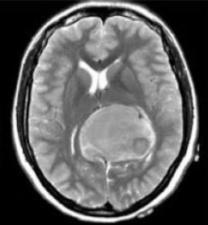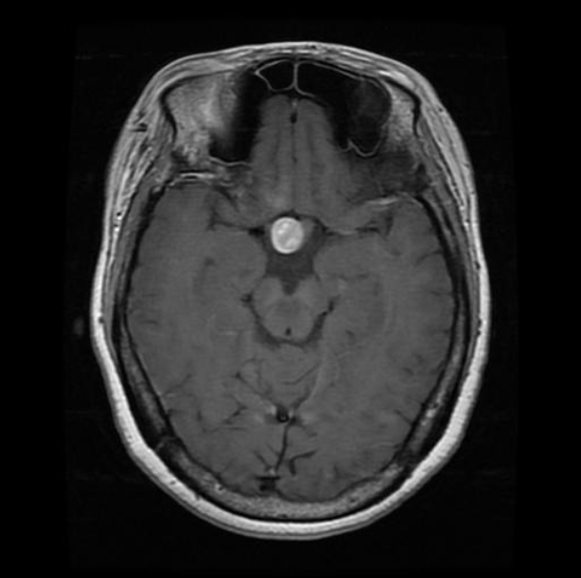
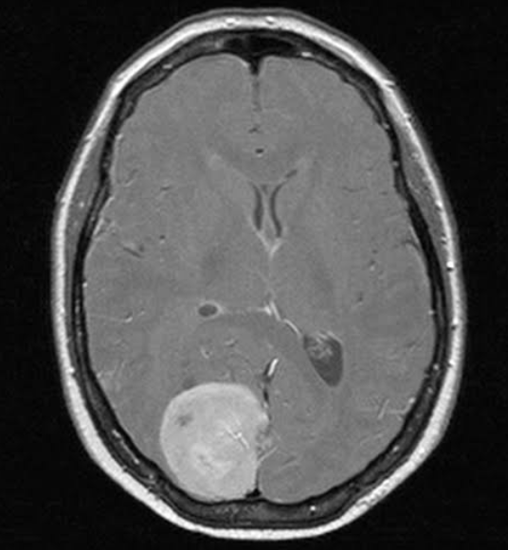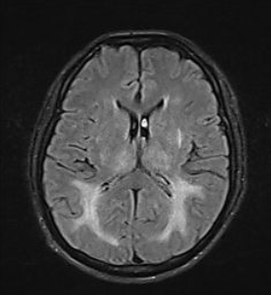
Fig 2. Images of brain MRI from the dataset

Preprocessing

Resizing

Images were resized to meet the input requirements of each CNN architecture:
The images were resized to 224x 224 pixels for VGG16, DenseNet12.
The image was resized to 299x299 pixels for Inception Net, Xception Net.

Normalization

The values of the pixel of the images were normalized between range 0 and 1. This is done scaling the pixel value by 1/ 255. Normalization is essential for ensuring that the models converge efficiently during training.

Data Augmentation

To prevent overfitting, several data augmentation techniques were employed to the model to enhance the model.
A brief explanation of the data augmentation techniques was explained below.
- Random Rotation: Images were randomly rotated at various angles.
- Zooming: Random zooming was applied to simulate different scales.
- Shear Transformations: Affine transformations were performed to alter the geometry of the images.
- Horizontal Flip: Images were randomly flipped horizontally.
Data augmentation was dynamically applied using Keras's Image Data Generator, ensuring that each training batch contained a variety of transformed images, which helped the models generalize better to unseen data.

Training the Network

The models were trained using a consistent training procedure to ensure comparability. The Adam optimizer was used with an initial learning rate of 0.001. For loss function, Categorical cross-entropy was used as it is appropriate for multi-class classification problem for the research.
The batch size was set to 32 which balances computational efficiency and model convergence.

Each model underwent 10 epochs of training. Early stopping technique was implemented with a patience of 5 epochs, to prevent overfitting by monitoring the validation loss. Training was conducted on a high-performance computing environment without GPU, ensuring that the models could be trained efficiently within the set number of epochs and result of the training process using different architectures are given in Table 2.

- COMPARISON OF OF DIFFERNET CNN ARCHITECTURES DURING TRAINING
CNN BASE | Training Accuracy | Testing Accuracy
VGG-16 | 0.9648 | 0.1044
Inception Net | 0.9557 | 0.8829
Xception Net | 0.9655 | 0.4588
DenseNet 121 | 0.9631 | 0.2446

Evaluation Metrics
The performance of each model was analyzed by plotting accuracy and loss curves over the certain training period.

- Accuracy Curves

The Accuracy Curves shows the proportion of input that the model correctly classified from the total number of instances. We can see that the accuracy increases with increase in epochs.

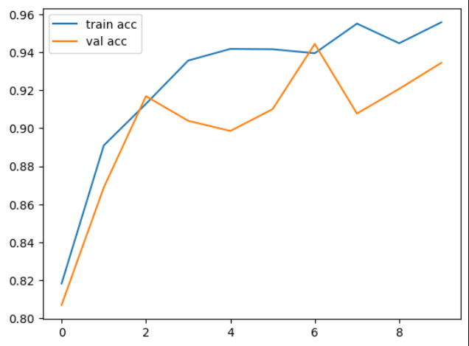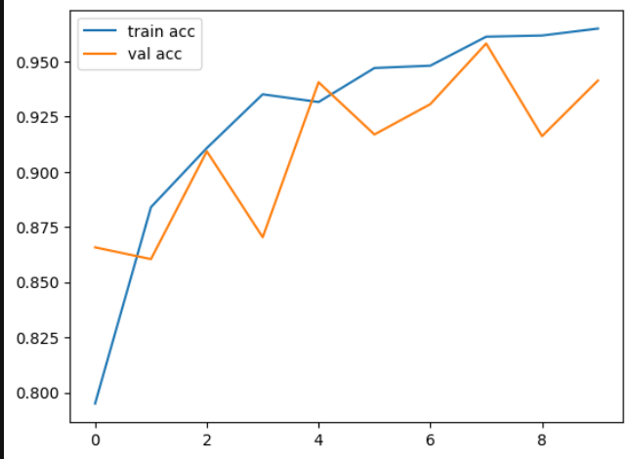
Fig 3(a). Accuracy curve of VGG -16 and Inception Net

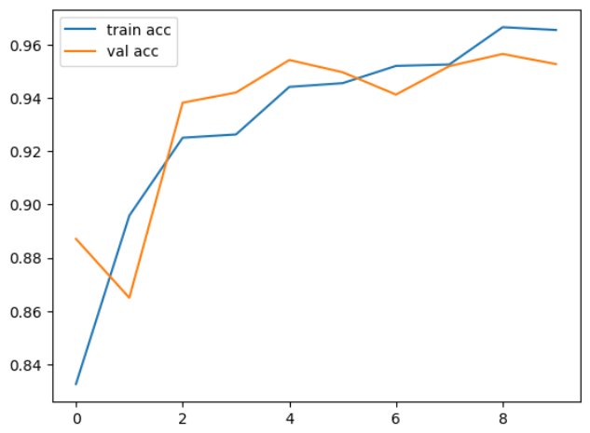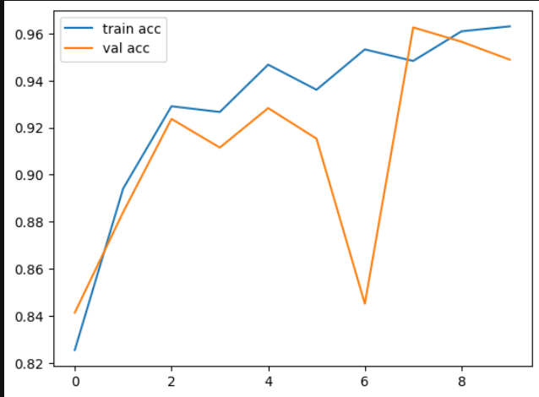
Fig 3(b). Accuracy curve of Xception Net and DenseNet

Fig 3(a) represents the accuracy curve of VGG 16 nad Inception net architecture.
Fig 3 (b) represent the accuracy curve of Xceprtion Net and DenseNet architectures.

- Loss Curves

The Loss Curves show how model's error decreases as it learns, which indicates an improvement in its performance.
A decreasing training loss indicates improved predictions on the training data, while the overfitting is identified by validation loss, especially if it begins to rise while the training loss continues to decrease.

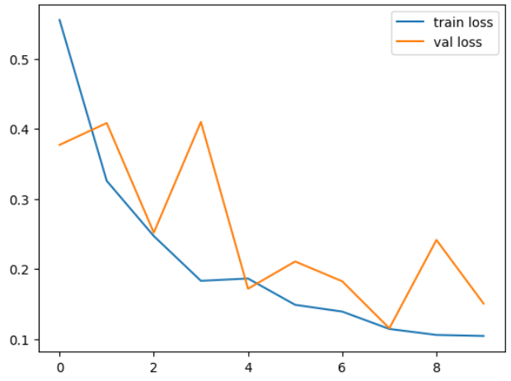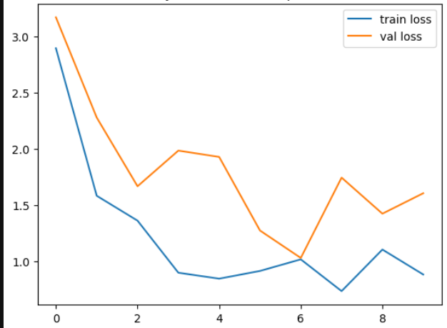
Fig 4(a) Loss curve of VGG -16 and Inception Net

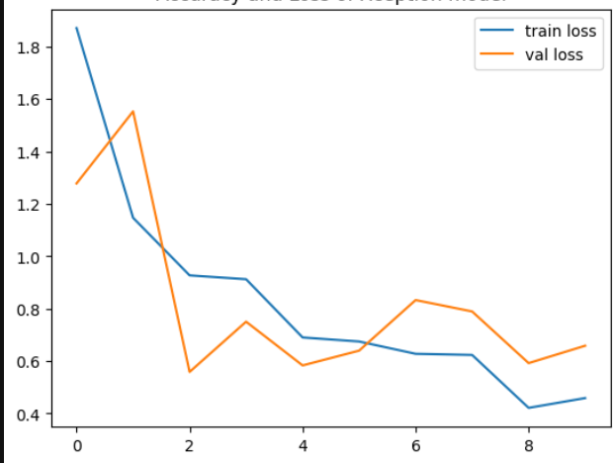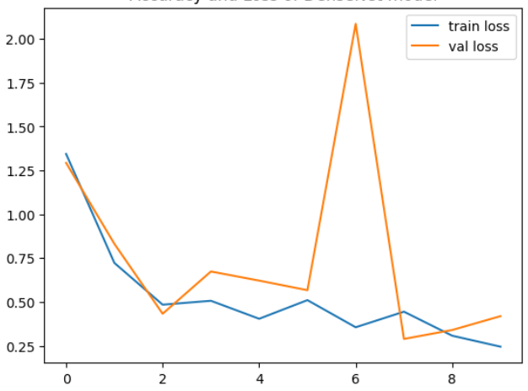
Fig 4(b). Loss curve of Xception Net and DenseNet

Fig 4(a) represents the loss curve of VGG 16 nad Inception net architecture.
Fig 4 (b) represent the loss curve of Xceprtion Net and DenseNet architectures.

V. EXPERIMENTAL RESULTS

The experimental results presented in this section detail the performance of the four deep learning models which used the CNN bases VGG16, InceptionV3, Xception, and DenseNet121 on the brain tumor classification task. The models were evaluated based on their accuracy and loss metrics, which were recorded over the course of training on the dataset described earlier. The table 3 represents the accuracy of various models.
- COMPARISON OF DIFFERENT CNN ARCHITECTURES DURING TESTING
CNN BASE | Training Accuracy | Testing Accuracy
VGG-16 | 0.9413 | 0.1506
Inception Net | 0.9344 | 1.6060
Xception Net | 0.9527 | 0.6586
DenseNet 121 | 0.9489 | 0.4187

In this study, a practical application was developed and deployed to facilitate the real time accurate detection and classification of brain tumors from MRI scans. The application integrates the trained CNN model, enabling users to upload MRI images and receive instant classification into four categories: glioma, meningioma, no tumor, and pituitary. The application demonstrated robust performance with high accuracy for detecting and classifying the brain tumor.

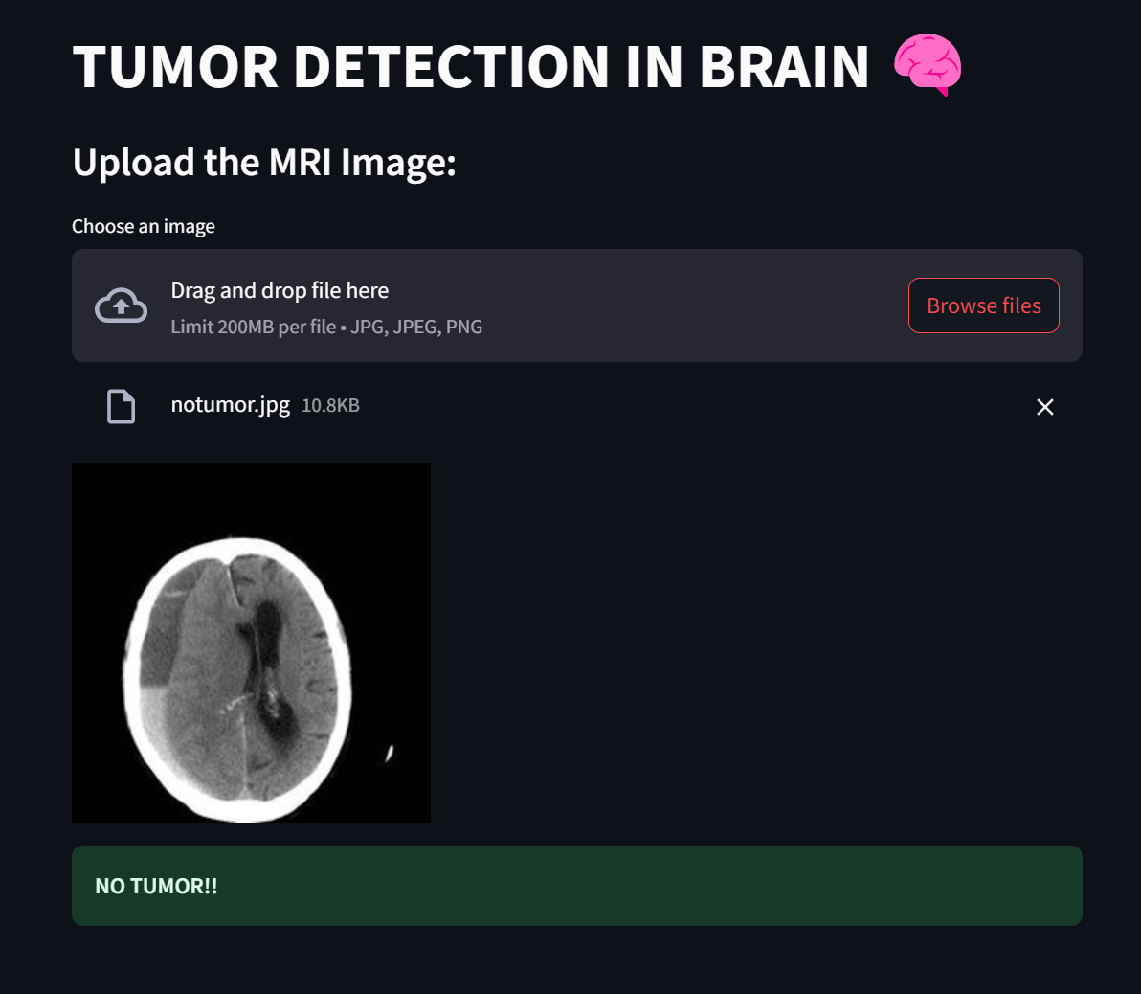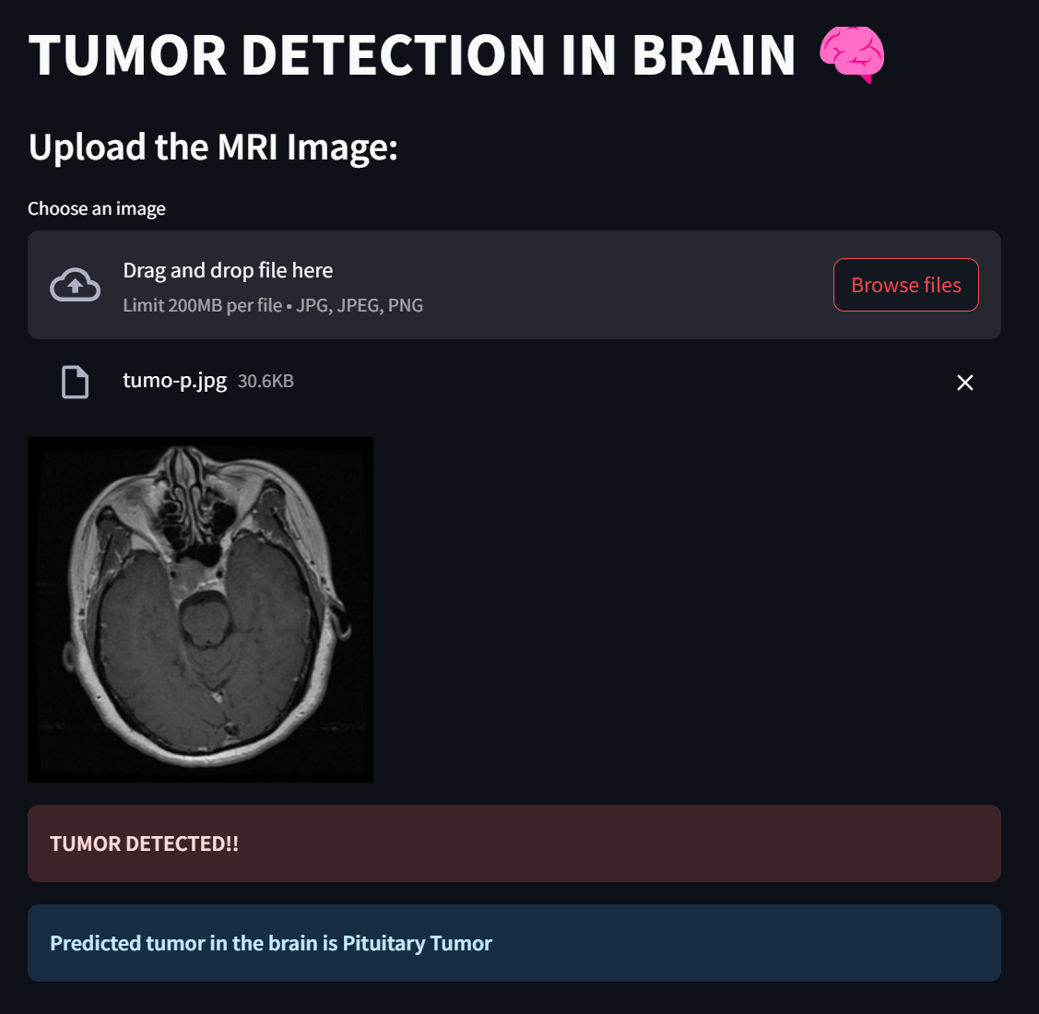
Fig 5 (a) . Prediction of Tumor as No tumor and Pituitary

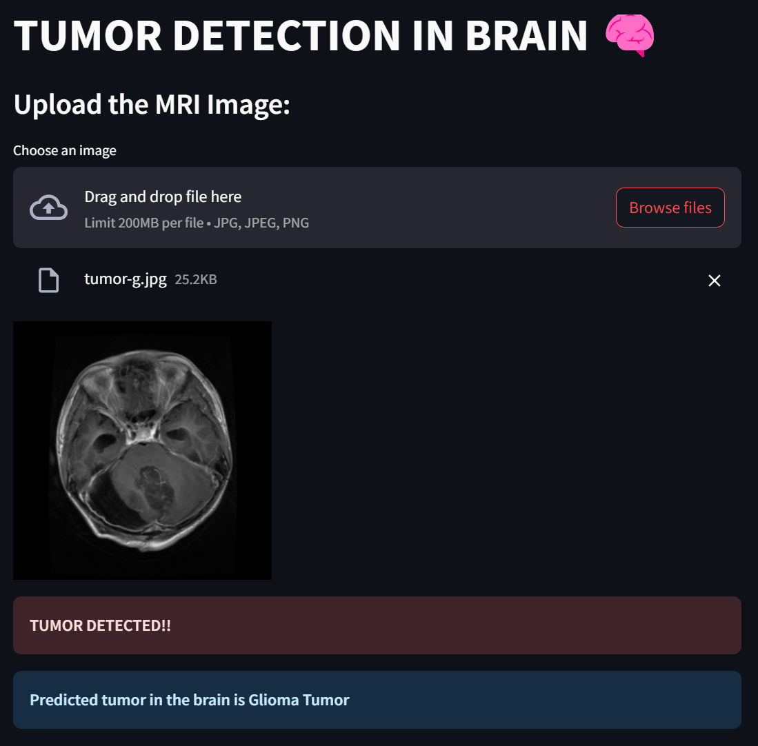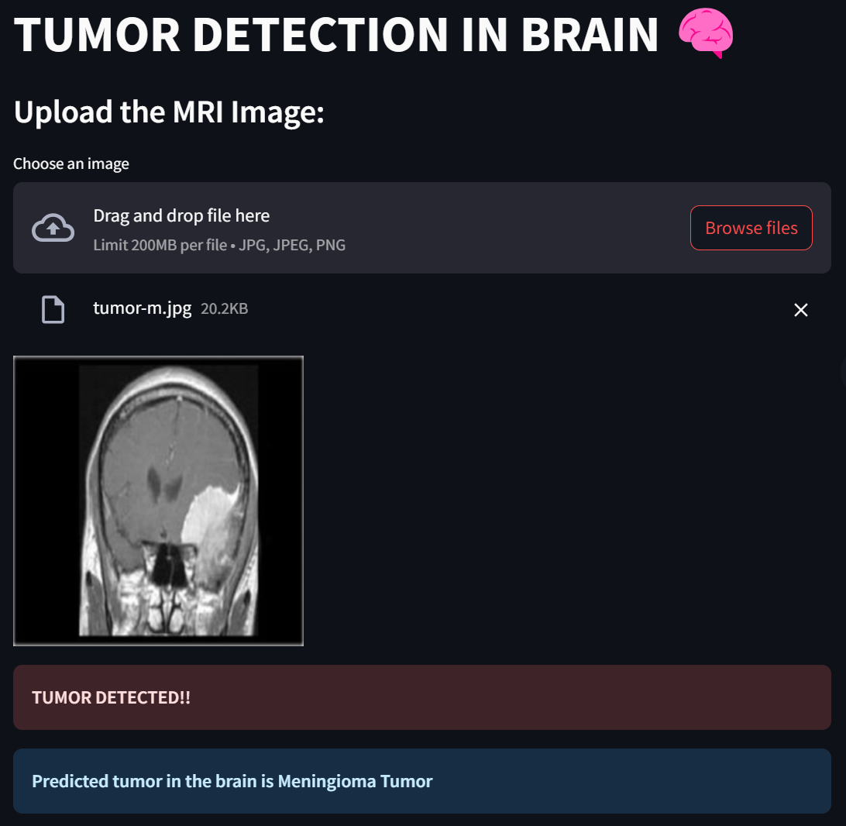
Fig 5 (b) . Prediction of Tumor as Glioma and Meningioma

The prediction of No tumor and Pituitary tumor are given in Fig 5(a) and prediction of Glioma and Meningioma tumor are given in Fig 5(b).

CONCLUSIONS

In this paper, we evaluated several Convolutional Neural Network (CNN) architectures like VGG-16, Inception Net, Xception Net, and DenseNet for brain tumor classification using MRI images.VGG-16 emerged as the top performer, achieving the highest testing accuracy of 96.48% and the lowest test loss of 0.10, indicating its superior ability to generalize to unseen data. Dense Net also showed strong results. Inception Net and Xception Net performed similarly, but both struggled with higher testing losses, suggesting potential overfitting. VGG-16 performed better than other pretrained model due to the nature of the dataset and hyperparameters. Future work could involve hyperparameter tuning, more robust data augmentation, exploring ensemble methods, using models pre-trained on medical imaging datasets, and incorporating explainability techniques to further enhance the models' performance and reliability for medical applications.

References
- Pereira, S., Pinto, A., Alves, V., & Silva, C. A. (2016). Brain Tumor Segmentation Using Convolutional Neural Networks in MRI Images. IEEE Transactions on Medical Imaging, 35(5), 1240-1251.
- Havaei, M., Davy, A., Warde-Farley, D., Biard, A., Courville, A., Bengio, Y., ... & Jodoin, P. M. (2017). Brain Tumor Segmentation with Deep Neural Networks. Medical Image Analysis, 35, 18-31.
- Kamnitsas, K., Ledig, C., Newcombe, V. F., Simpson, J. P., Kane, A. D., Menon, D. K., ... & Rueckert, D. (2017). Efficient Multi-Scale 3D CNN with Fully Connected CRF for Accurate Brain Lesion Segmentation. Medical Image Analysis, 36, 61-78.
- Nodirov, J., Abdusalomov, A. B., & Whangbo, T. K. (2022). Attention 3D U-Net with Multiple Skip Connections for Segmentation of Brain Tumor Images. Sensors, 22(17), 6501.
- Isin, A., Direkoglu, C., & Sah, M. (2016). Review of MRI-based Brain Tumor Image Segmentation Using Deep Learning Methods. Procedia Computer Science, 102, 317-324.
- Dong, H., Yang, G., Liu, F., Mo, Y., & Guo, Y. (2017). Automatic brain tumor detection and segmentation using U-Net based fully convolutional networks. In Medical Image Understanding and Analysis: 21st Annual Conference, MIUA 2017, Edinburgh, UK, July 11–13, 2017, Proceedings 21 (pp. 506-517). Springer International Publishing.
- Zhang W, Wu Y, Yang B, Hu S, Wu L, Dhelimd S. Overview of Multi-Modal Brain Tumor MR Image Segmentation. Healthcare (Basel). 2021 Aug 16;9(8):1051. doi: 10.3390/healthcare9081051. PMID: 34442188; PMCID: PMC8392341.
- Myronenko, A. (2019). 3D MRI brain tumor segmentation using autoencoder regularization. In Brainlesion: Glioma, Multiple Sclerosis, Stroke and Traumatic Brain Injuries: 4th International Workshop, BrainLes 2018, Held in Conjunction with MICCAI 2018, Granada, Spain, September 16, 2018, Revised Selected Papers, Part II 4 (pp. 311-320). Springer International Publishing.
- Zhou, Z., Rahman Siddiquee, M. M., Tajbakhsh, N., & Liang, J. (2018). Unet++: A nested u-net architecture for medical image segmentation. In Deep Learning in Medical Image Analysis and Multimodal Learning for Clinical Decision Support: 4th International Workshop, DLMIA 2018, and 8th International Workshop, ML-CDS 2018, Held in Conjunction with MICCAI 2018, Granada, Spain, September 20, 2018, Proceedings 4 (pp. 3-11). Springer International Publishing.
- Liu, Z., Li, W., Cao, G., Wen, L., & Ma, Y. (2020). Dense Fully Convolutional Network with Self-attention for Brain Tumor Segmentation. In Proceedings of the IEEE Conference on Computer Vision and Pattern Recognition Workshops (pp. 1-8).
- I. Goodfellow, Y. Bengio and A. Courville, Deep learning, The MIT Press, 2017, p. 330.
- M. Nielson, Neural Networks and Deep Learning, Determination press, 2015, p. 174.
- N. Srivastava, G. Hinton, A. Krizhevsky, I. Sutskever, R. Salakhutdinov, “{Dropout: A simple way to prevent neural networks from overfitting,” Journal of Machine Learning Research, Vol. 15, No. 1, 2014, pp. 1929-1958.
- Chollet, F. (2021). Deep learning with Python. Simon and Schuster.
- Ioffe, S. (2015). Batch normalization: Accelerating deep network training by reducing internal covariate shift. arXiv preprint arXiv:1502.03167.
- Foster, D. (2022). Generative deep learning. " O'Reilly Media, Inc.".
- Simonyan, K., & Zisserman, A. (2014). Very Deep Convolutional Networks for Large-Scale Image Recognition. arXiv preprint arXiv:1409.1556.
- He, K., Zhang, X., Ren, S., & Sun, J. (2016). Deep Residual Learning for Image Recognition. In Proceedings of the IEEE Conference on Computer Vision and Pattern Recognition (CVPR), 770-778.
- Szegedy, C., Vanhoucke, V., Ioffe, S., Shlens, J., & Wojna, Z. (2016). Rethinking the Inception Architecture for Computer Vision. In Proceedings of the IEEE Conference on Computer Vision and Pattern Recognition (CVPR), 2818-2826.
- Chollet, F. (2017). Xception: Deep Learning with Depthwise Separable Convolutions. In Proceedings of the IEEE Conference on Computer Vision and Pattern Recognition (CVPR), 1251-1258.
- Huang, G., Liu, Z., Van Der Maaten, L., & Weinberger, K. Q. (2017). Densely Connected Convolutional Networks. In Proceedings of the IEEE Conference on Computer Vision and Pattern Recognition (CVPR), 4700-4708.
- Islam, M. M., Wang, Z., Iqbal, M. A., & Song, G. (2018, December). Brain Tumor Segmentation on MR Images Using Anisotropic Deeply Supervised Convolutional Neural Network. In Proceedings of the 2018 2nd International Conference on Video and Image Processing (pp. 226-230)
- Menachery, J., Anand, I. K., & Thiruthuvanathan, M. M. (2023, April). Brain Tumor Detectin Using Deep Learning Model. In 2023 IEEE International Conference on Contemporary Computing and Communications (InC4) (Vol. 1, pp. 1-6). IEEE.
- Uppada, S. K., & Patel, P. (2023). An image and text-based multimodal model for detecting fake news in OSN’s. Journal of Intelligent Information Systems, 61(2), 367-393.
- Mahamud, E., Fahad, N., Assaduzzaman, M., Zain, S. M., Goh, K. O. M., & Morol, M. K. (2024). An explainable artificial intelligence model for multiple lung diseases classification from chest X-ray images using fine-tuned transfer learning. Decision Analytics Journal, 12, 100499.
- Farajzadeh, N., Sadeghzadeh, N., & Hashemzadeh, M. (2023). Brain tumor segmentation and classification on MRI via deep hybrid representation learning. Expert Systems with Applications, 224, 119963.
- Wang, G., Song, T., Dong, Q., Cui, M., Huang, N., & Zhang, S. (2020). Automatic ischemic stroke lesion segmentation from computed tomography perfusion images by image synthesis and attention-based deep neural networks. Medical Image Analysis, 65, 101787.
- Crimi, A., & Bakas, S. (Eds.). (2021). Brainlesion: Glioma, Multiple Sclerosis, Stroke and Traumatic Brain Injuries: 6th International Workshop, BrainLes 2020, Held in Conjunction with MICCAI 2020, Lima, Peru, October 4, 2020, Revised Selected Papers, Part I (Vol. 12658). Springer Nature.
- Panda, M., Abraham, A., Gopi, B., & Ajith, R. (Eds.). (2024). Computational Intelligence for Oncology and Neurological Disorders: Current Practices and Future Directions. CRC Press.
- Dash, S., Pani, S. K., Rodrigues, J. J., & Majhi, B. (Eds.). (2022). Deep learning, machine learning and IoT in biomedical and health informatics: techniques and applications. CRC Press.
- Nimma, D., & Uddagiri, A. (2024). Advancements in Deep Learning Architectures for Image Recognition and Semantic Segmentation. International Journal of Advanced Computer Science & Applications, 15(8).
- Das, S., Dubey, R., Jena, B., Tsai, L. W., & Saxena, S. (2024). WU-Net++: A novel enhanced Weighted U-Net++ model for brain tumor detection and segmentation from multi-parametric magnetic resonance scans. Multimedia Tools and Applications, 1-24.
- Crimi, A., & Bakas, S. (Eds.). (2021). Brainlesion: Glioma, Multiple Sclerosis, Stroke and Traumatic Brain Injuries: 6th International Workshop, BrainLes 2020, Held in Conjunction with MICCAI 2020, Lima, Peru, October 4, 2020, Revised Selected Papers, Part I (Vol. 12658). Springer Nature.
- Dawood, T. A., Hashim, A. T., & Nasser, A. R. (2023). Advances in Brain Tumor Segmentation and Skull Stripping: A 3D Residual Attention UNet Approach. Traitement du Signal, 40(5).
- Yilmaz, V. S., Akdag, M., Dalveren, Y., Doruk, R. O., Kara, A., & Soylu, A. (2023). Investigating the Impact of Two Major Programming Environments on the Accuracy of Deep Learning-Based Glioma Detection from MRI Images. Diagnostics, 13(4), 651.
- Akkus, Z., Galimzianova, A., Hoogi, A., Rubin, D. L., & Erickson, B. J. (2017). Deep learning for brain MRI segmentation: state of the art and future directions. Journal of digital imaging, 30, 449-459.

